**What information about you do we collect?**

During our communications with you, over the telephone, face-to-face, in writing, via email, or via our website – www.candockireland.com– we may collect from you and keep a record of the following data in order to process your requests for our products and services.

**Personal data**: first name(s); surname; title; gender; home address; email address, contact telephone numbers; occupation, IP Address;

**Financial data:** bank details; payment card details (without verification #);

**Transactional data**: details of payments to and from your account with ourselves; invoices, statements and associated payments; and/or

**Usage Data**: Data on how you use our products and services. We may monitor your views on our website for the purposes of improving our service and helping to improve our business. This may include collating details such as your IP address and your device data including a general location.

Please advise us at any time if your information changes or is inaccurate, so that we can update our records and systems.

**How will information about you be used?**

We may use the information you provide to us in the following ways:

* To complete a pre-contract request for goods and services Our goods and services include berthing facilities, storage, boatyard repair, maintenance & re-fit work, marine services and new-build contracts, new boat sales, yacht brokerage, and tenancies;
* To fulfil our contractual obligations to you in respect of the goods and services detailed above;
* For the necessary legitimate interests in relation to the purchase of a vessel; the provenance of the vessel, including the historical vessel chain of title.
* We may share your personal data as detailed on vessel title, and legal documentation with future owners, the Registry of Ships, lawyers, banks and insurers;
* We may share your personal for warranty purposes with the manufacturers of the vessel, engines, electronics and component parts for the purposes of providing a full warranty to you;
* For the purposes of direct marketing (but only with your consent which you can withdraw at any time);
* Should you incur harm, or, have an accident whilst on our premises, we may share your data with medical personnel should the need arise in order to protect your life.

**Who do we share your information with?**

We may share your personal data with our subsidiaries and associated companies within the Berthon Boat Company Ltd Group:

* West Cork Civil Engineering

We may also share your data with:

* Our associated vessel manufacturers;
* The manufacturers of the new vessel’s component parts for warranty purposes;
* Banks, insurance companies, marina operators, lawyers; surveyors; brokers;
* Future vessel owners, and
* Our I.T. Service and Website providers

We will only share your data where it is necessary to fulfil our obligations, or where it is necessary to protect our legitimate interests where there is no detrimental effect on your fundamental rights and freedoms.

**How long do we keep your Information**

We will hold your personal information on our records and systems for no longer than necessary for the purpose for which the information was collected.

Where you withdraw your consent for us to hold your data, your personal information will be deleted from our records and systems within one calendar month. Please be advised that without your consent we may be unable to provide the products and services that you have requested.

**Your Right to Restrict, Object to & Withdraw consent**

You are entitled to object, restrict and withdraw your consent for us to hold your data, at any time. Please be advised that where we are required to hold your data under other lawful bases for processing, we may not be able to remove your data in line with your request.

**Your Right to Access your Personal Information**

You have the right to request sight of personal data and information that we hold about you. You will need to provide two forms of confirmation of your identity with this request which can include;

* Valid Passport
* Driving license
* Utility Bill or bank statement dated within the last 6 months

**International Transfers**

To fulfil our obligations to you for our products and services it may be necessary for us at times, to transfer your personal data outside the UK and EEA during the course of business. We will only do so where the organisation and third countries receiving and processing your data have adequate safeguards in place, and the protections afforded by those countries do not undermine the protection afforded by the GDPR standards.

**Complaints Procedure**

You have the right to lodge a complaint with a supervisory if you do not think we are handling your data correctly.

**Other Websites**

Our website contains links to other websites, this privacy policy only applies to this website and not the links provided.

**Changes to our privacy policy**

We keep our privacy policy under regular review and we will place any updates on this web page.

# Cookies In Use on This Site – and how they Benefit You

This Cookies Policy explains how we use cookies on our website at www.candockireland.com.

**What are cookies?**

A cookie is a small text file of letters and numbers that we store on your device when you visit our website. Cookies are used for a number of reasons. These include to ensure a website works correctly or more efficiently, as well as to record information about website users and how they interact with a site.

**What cookies do we use?**

The table below lists the cookies we use on our website and what they do. The ‘duration’ of a cookie is how long it is active for. Once the duration ends, your browser will usually automatically delete the cookie. ‘Session’ cookies are automatically deleted when you close all your browser windows.

The below list details the cookies used in our website.

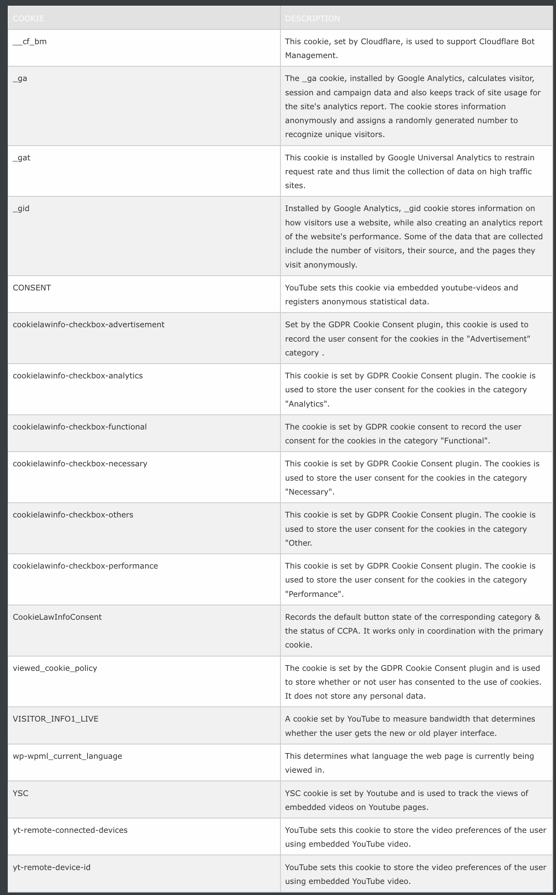

**How do I change my cookie settings?**

You can also use your browser settings to block all cookies but you may not be able to access parts of our website as a result. To find out more about cookies visit [www.aboutcookies.org](http://www.aboutcookies.org/)or [www.allaboutcookies.org](http://www.allaboutcookies.org/).

**Third party cookies**

We use Google Analytics and YouTube cookies on our website. These are third party cookies operated by Google. You can view Google’s Privacy Policy here: <https://policies.google.com/privacy>.

To opt out of being tracked by Google Analytics across all websites, please visit <http://tools.google.com/dlpage/gaoptout>.

**Monotype Imaging Fonts**

Fonts.com fonts are in use on this website. Fonts.com is a service that provides access to a library of fonts for use in desktop applications and websites.